**Sarthak Tajane**

**150096724109**

**User Management in DBMS**

**Practical 1: Create and Manage Users**

**Objective: Create different database users (User1 and User2)with specific privileges.**

* **Create a new database user.**
* **Grant and revoke privileges (SELECT, INSERT, DELETE, UPDATE).**
* **Display user privileges.**

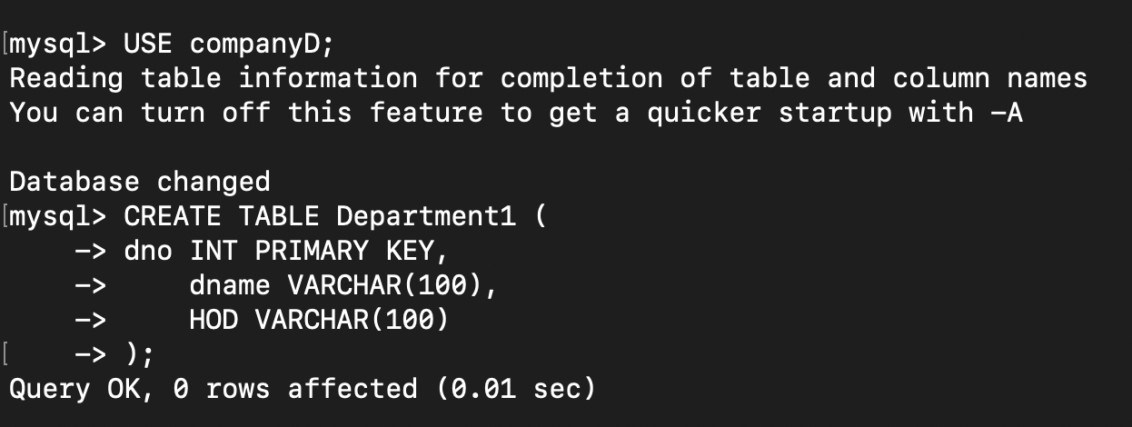

**Indexing in DBMS**

**Practical 2: Implement Indexing on a Project Table**

**Objective: Improve query performance using indexing.**

* **Create Project table with a primary key.**
* **Insert multiple user records.**
* **Create an index on the Budget column.**
* **Display index.**
* **Remove an index and analyze the impact.**
* **Composite Indexing – Create an index on dame and HOD and analyze query performance.**

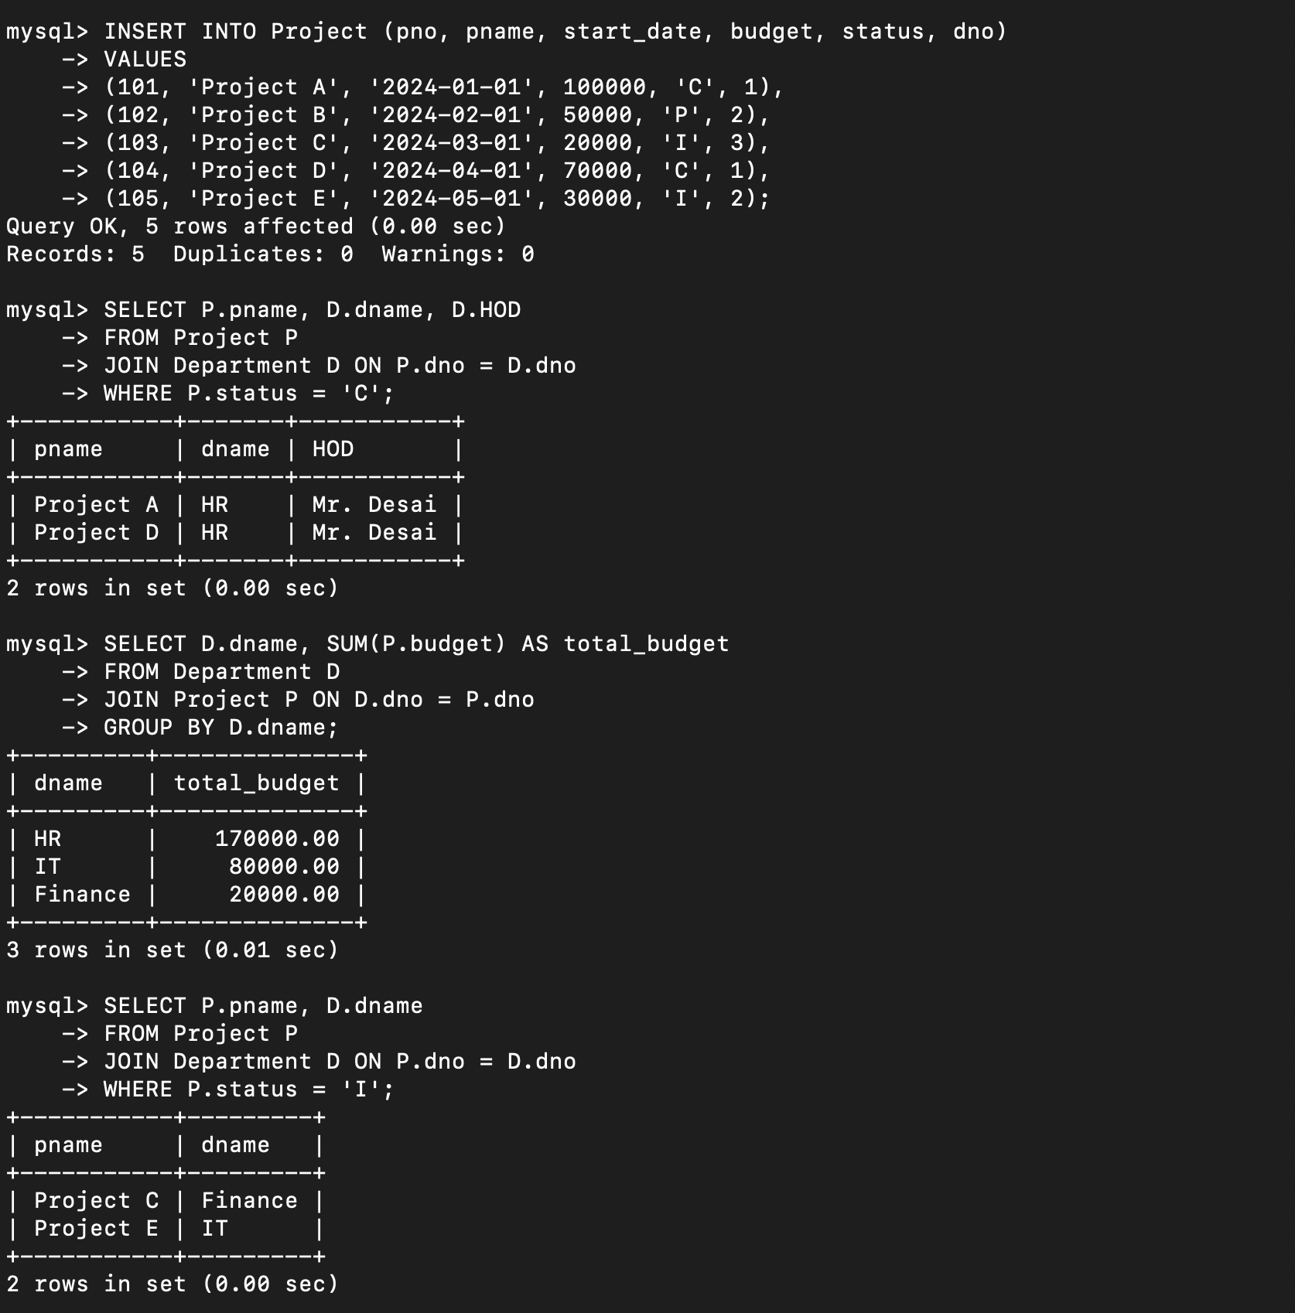

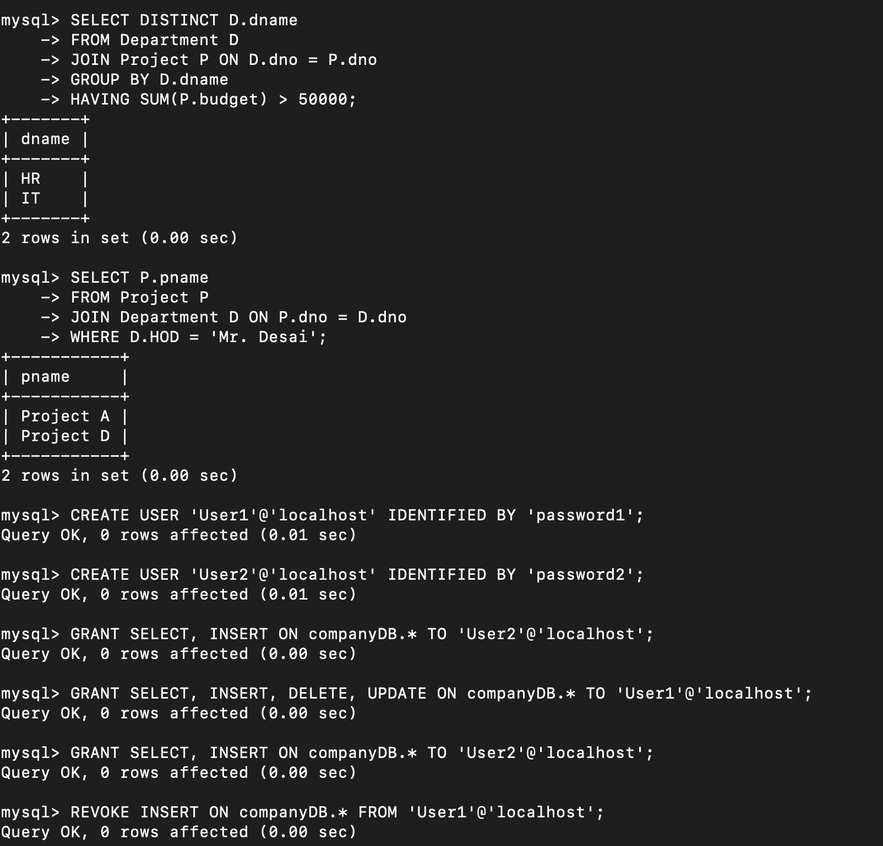

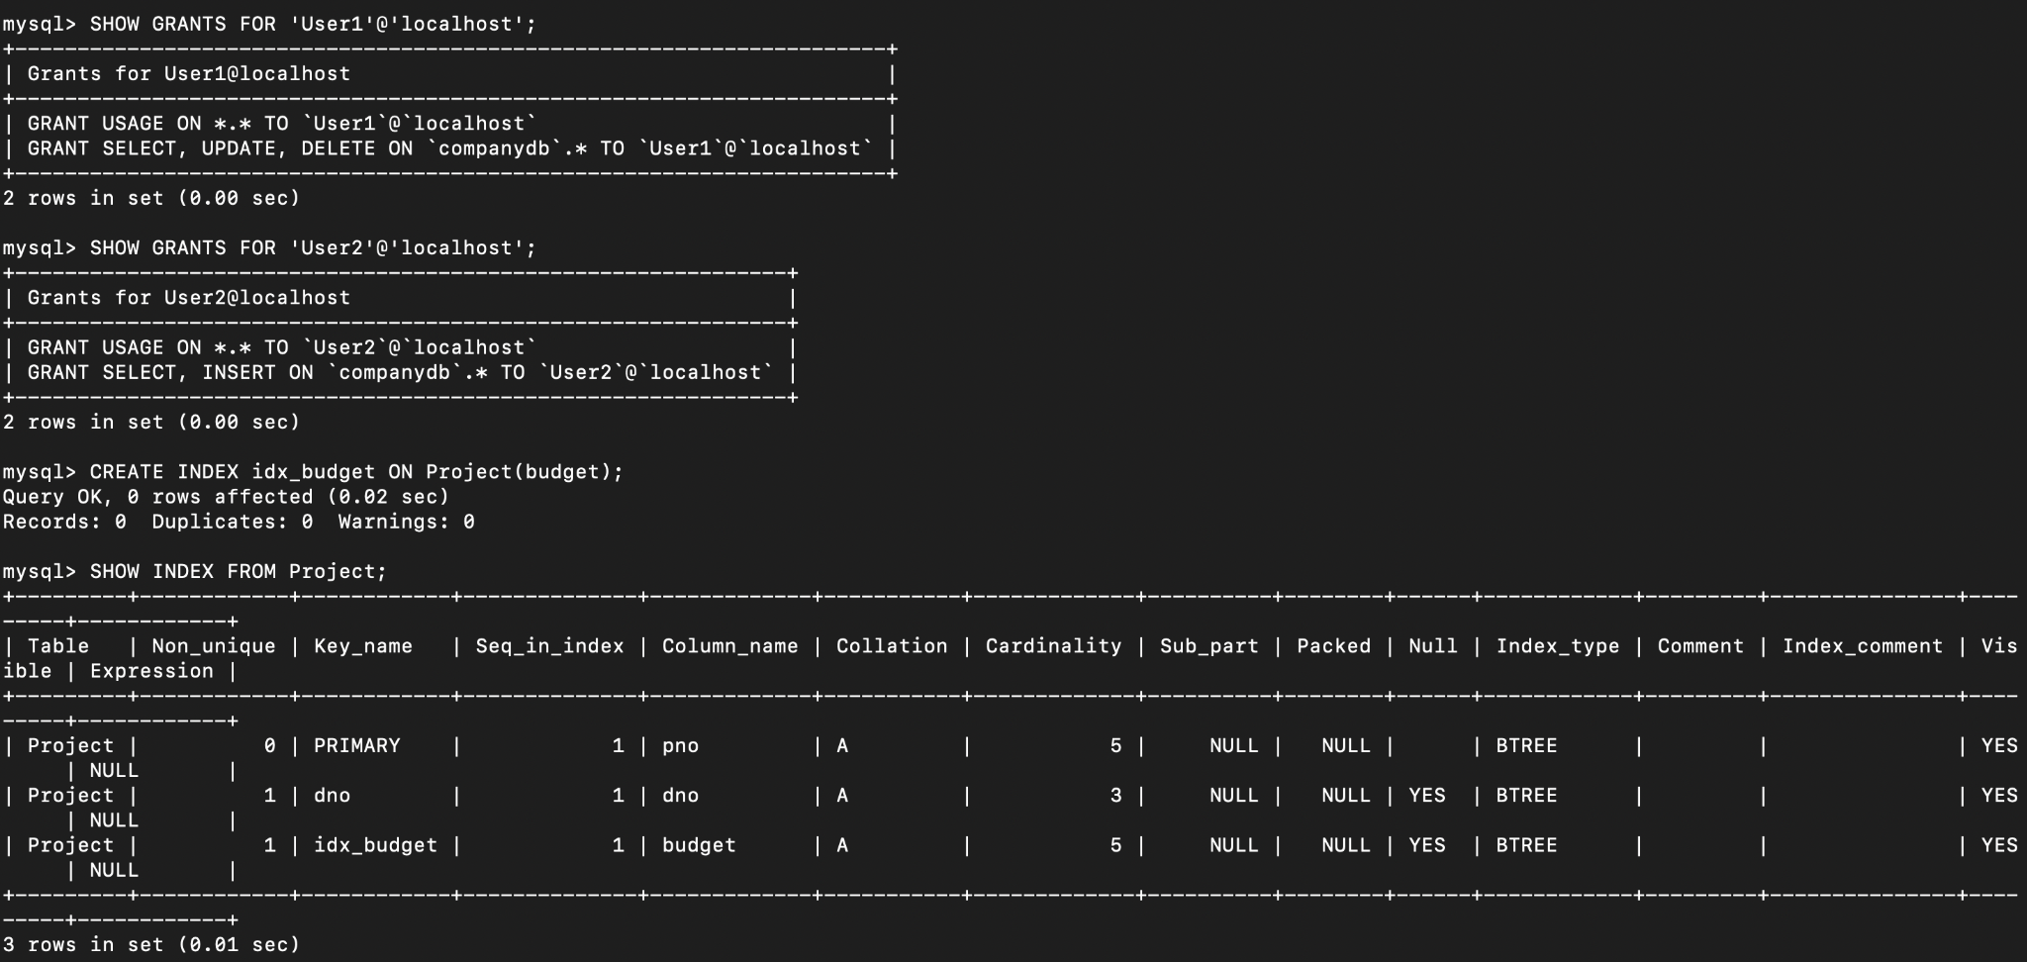

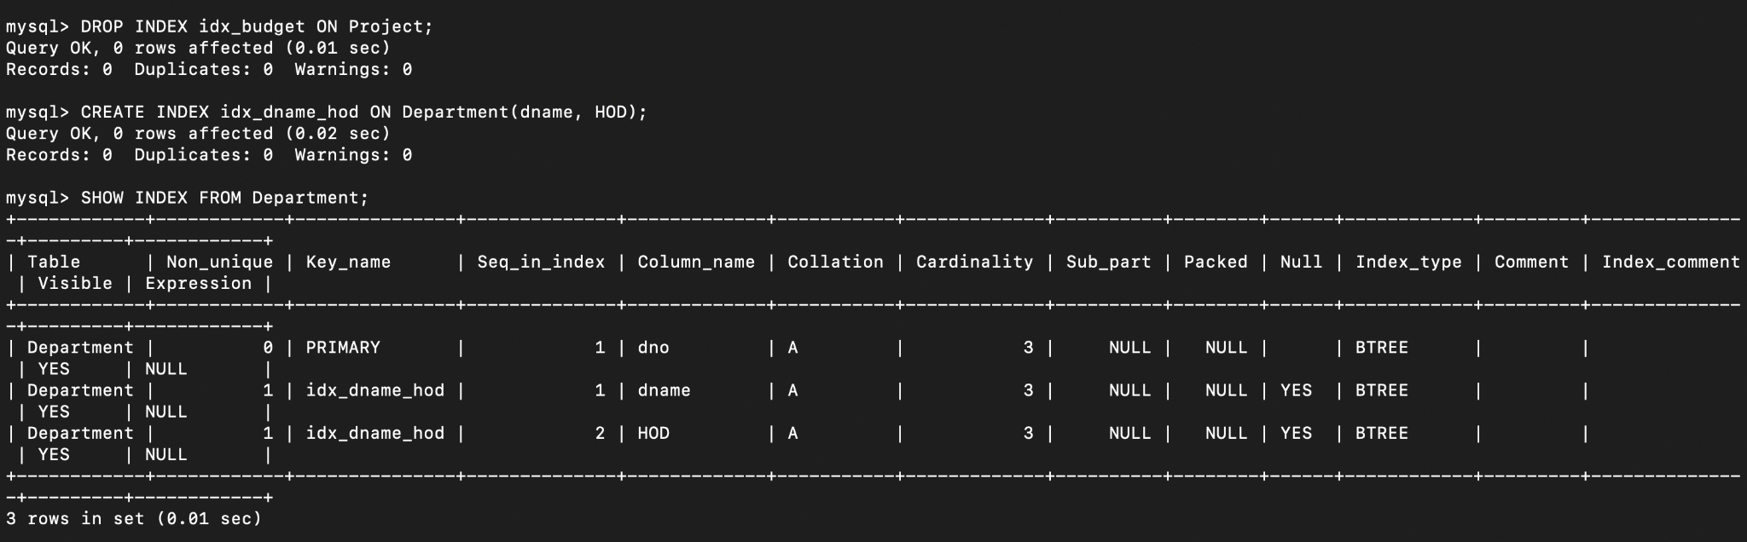

**Role Management in DBMS**

**Practical 3: Create and Assign Roles**

**Objective: Manage user roles and permissions efficiently.**

* **Create different roles (Admin, Editor, Viewer).**
* **Assign privileges to roles.(select,insert,update privileges)**
* **Assign roles to users and test access levels.**

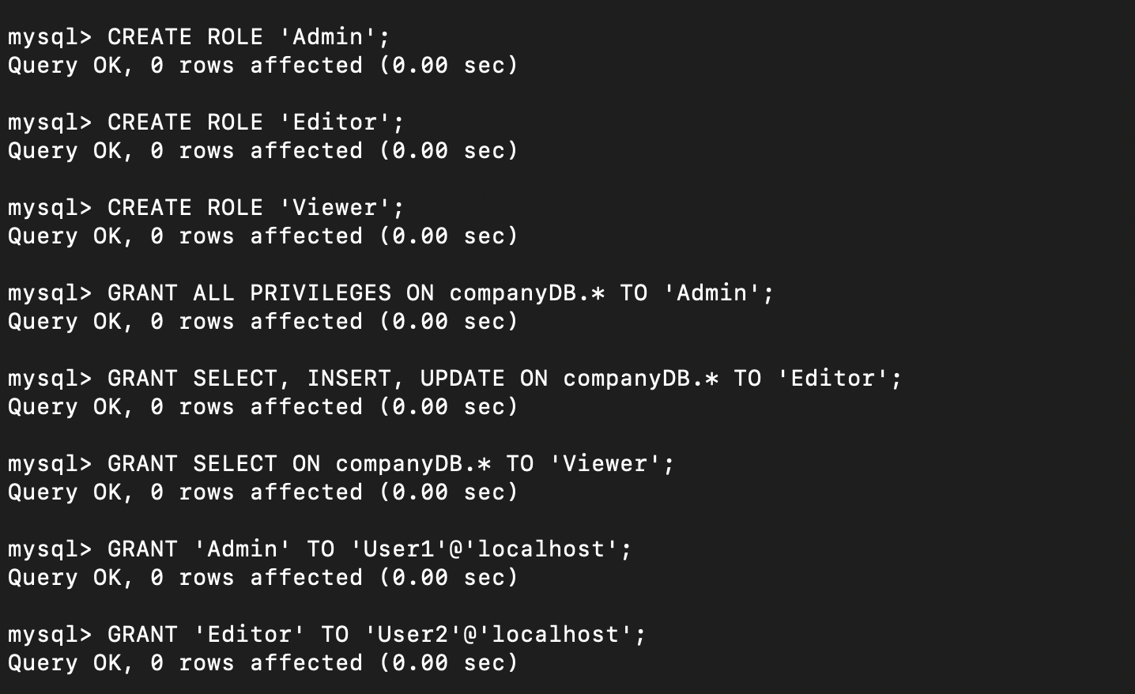

**Triggers in DBMS**

**Create a Trigger to Prevent Invalid Salary Updates**

